Table codes project 1745

Tables:
tbl_new_cohort_profile_one – done
tbl_new_cohort_profile
tbl_new_cohort_table_new
tbl_new_race_link
tbl_IMD_info

tbl_new_cohort_profile_one

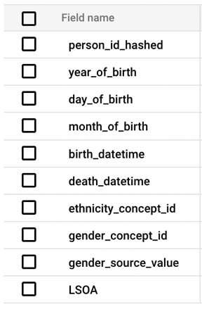
CREATE TABLE `yhcr-prd-bradfor-bia-core.CB_1745.tbl_new_cohort_profile_one` as (
SELECT * FROM
(SELECT DISTINCT person_id_hashed FROM `yhcr-prd-bradfor-bia-core.CB_1745.tbl_bloodpressure_data` ORDER BY person_id_hashed)

LEFT JOIN
(Select distinct year_of_birth, day_of_birth, month_of_birth, birth_datetime, death_datetime, ethnicity_concept_id, gender_concept_id, gender_source_value, person_id_hashed FROM `yhcr-prd-bradfor-bia-core.CB_1745.person`)
USING (person_id_hashed)

LEFT JOIN
(select distinct LSOA, person_id_hashed FROM `yhcr-prd-bradfor-bia-core.CB_1745.personLSOA`)
USING (person_id_hashed)
)

tbl_new_cohort_profile
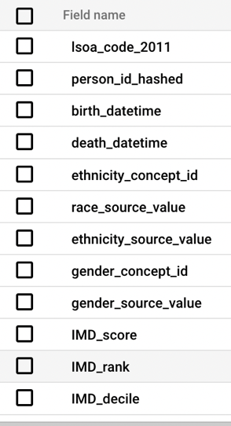

Code:
CREATE OR REPLACE TABLE `yhcr-prd-bradfor-bia-core.CB_1745.tbl_new_cohort_profile` as (
SELECT * FROM
(SELECT DISTINCT person_id_hashed FROM `yhcr-prd-bradfor-bia-core.CB_1745.tbl_bloodpressure_data` ORDER BY person_id_hashed)

LEFT JOIN
(Select distinct birth_datetime, death_datetime, ethnicity_concept_id, race_source_value, ethnicity_source_value, gender_concept_id, gender_source_value, person_id_hashed FROM `yhcr-prd-bradfor-bia-core.CB_1745.person`)
USING (person_id_hashed)

LEFT JOIN
(select distinct LSOA AS `lsoa_code_2011`, person_id_hashed FROM `yhcr-prd-bradfor-bia-core.CB_1745.personLSOA`)
USING (person_id_hashed)

LEFT JOIN
(SELECT DISTINCT
lsoa_code_2011,
index_of_multiple_deprivation_imd_score as IMD_score,
index_of_multiple_deprivation_imd_rank_where_1_is_most_depriv as IMD_rank,
index_of_multiple_deprivation_imd_decile_where_1_is_most_depr as IMD_decile
FROM `yhcr-prd-bradfor-bia-core.ref_Lookups.lkp_IMD_2019`)
USING (lsoa_code_2011)
)

tbl_new_cohort_table_new

Columns to remove:
Filename, CoefficientOfVariability, DiaryEventAnnotation, Excluded, PatientNumber, cb-datasetref

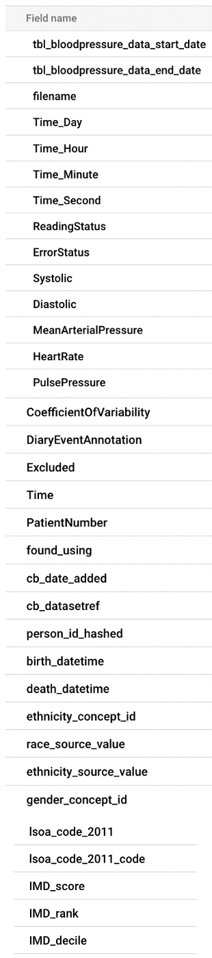
Code:
CREATE OR REPLACE TABLE `yhcr-prd-bradfor-bia-core.CB_1745.tbl_new_cohort_profile_new` AS
SELECT
a.*,
b.birth_datetime,
b.death_datetime,
b.ethnicity_concept_id,
b.race_source_value,
b.ethnicity_source_value,
b.gender_concept_id,
b.gender_source_value,
c.LSOA AS `lsoa_code_2011`,
d.lsoa_code_2011 as lsoa_code_2011_code,
d.index_of_multiple_deprivation_imd_score as IMD_score,
d.index_of_multiple_deprivation_imd_rank_where_1_is_most_depriv as IMD_rank,
d.index_of_multiple_deprivation_imd_decile_where_1_is_most_depr as IMD_decile
FROM
`yhcr-prd-bradfor-bia-core.CB_1745.tbl_bloodpressure_data` a
JOIN
`yhcr-prd-bradfor-bia-core.CB_1745.person` b
ON
a.person_id_hashed = b.person_id_hashed
LEFT JOIN
`yhcr-prd-bradfor-bia-core.CB_1745.personLSOA` c
ON
a.person_id_hashed = c.person_id_hashed
LEFT JOIN
`yhcr-prd-bradfor-bia-core.ref_Lookups.lkp_IMD_2019` d
ON
c.LSOA = d.lsoa_code_2011;

tbl_new_race_link
(Useful columns – concept_id, concept_name)
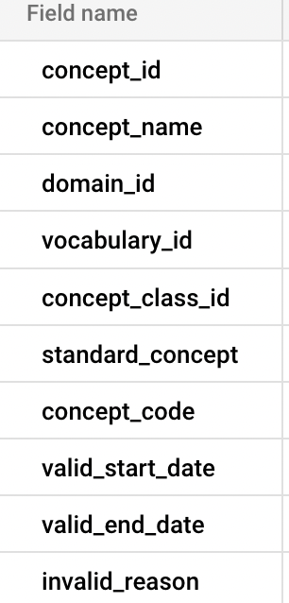

Code:

CREATE TABLE `yhcr-prd-bradfor-bia-core.CB_1745.tbl_new_race_link` as (
SELECT * FROM `yhcr-prd-bradfor-bia-core.CB_CDM_VOCAB.concept`
where concept_id in(select ethnicity_concept_id from `yhcr-prd-bradfor-bia-core.CB_1745.tbl_new_cohort_profile` )
)

tbl_IMD_info

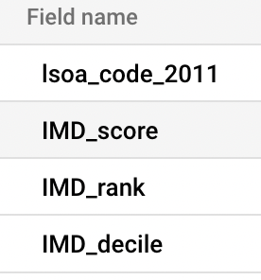
Code:

CREATE OR REPLACE TABLE `yhcr-prd-bradfor-bia-core.CB_1745.tbl_IMD_info` as (
SELECT * FROM
(SELECT DISTINCT
lsoa_code_2011,
index_of_multiple_deprivation_imd_score as IMD_score,
index_of_multiple_deprivation_imd_rank_where_1_is_most_depriv as IMD_rank,
index_of_multiple_deprivation_imd_decile_where_1_is_most_depr as IMD_decile
FROM `yhcr-prd-bradfor-bia-core.ref_Lookups.lkp_IMD_2019`)
ORDER BY IMD_decile asc )

In the end I want to end up with a table that has headings

Person ID hashed | Birth datetime | death datetime | Ethnicity_concept_id | Ethnicity | Gender_concept_id | Gender | LSOA code 2011 | IMD_score | IMD_rank | IMD_decile

